How to Time Synchronize a PMC-53M in ION Enterprise
The PMC-53M meter has time registers providing timestamps for data logs. It can be time synchronized through communication.
This technical note describes how to time synchronize a PMC-53M meter using ION Enterprise software.
It assumes that the users are familiar with ION Enterprise Modbus Device Importer utility and Modbus register maps of PMC-53M.

Reference documentation:
- PMC-53 Series User Manual V4.0A (20100623 - Final).pdf
- Modbus_Device_Importer.pdf
- Modbus_and_ION_Technology.pdf
- ION_Enterprise_5.6_User_Guide.pdf

The PMC-53M meter’s serial port has been configured with the following parameters:
- Type = RS485
- Baud rate = 9600
- Data Bits = 8
- Parity = None
- Stop Bits = 1
- UnitID=100

Creating the Modbus Map File for PMC-53M with ION Enterprise MDI Utility
Use the ION Enterprise Modbus Device Importer utility to configure the PMC-53M Modbus device (mapping information) and add it as a Device Type to the Network Configuration database (NOM). All time registers need to be pre-defined in the Modbus map file (.ion).
- Launch Management Console. Enter the right user name and password to login. Two default user names (“guest” and “supervisor”) are both with a default password of “0” (zero).
- Navigate to ToolsSystemModbus Device Importer… from the Management Console user interface.
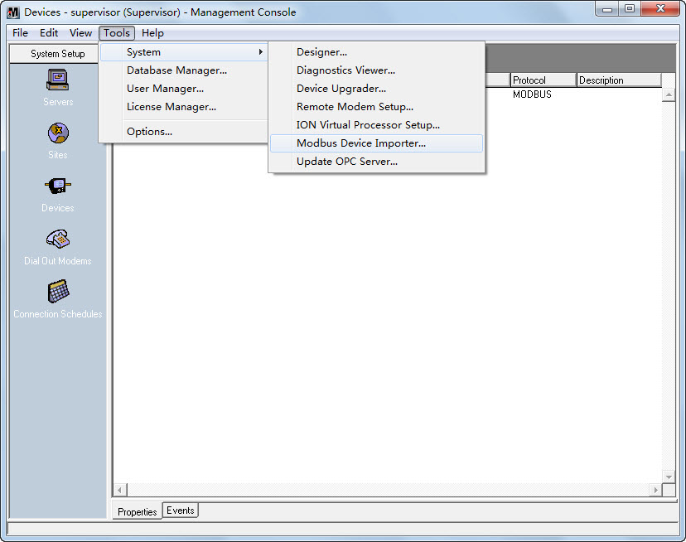
And the main console appears as follows (modbus_default.ion):
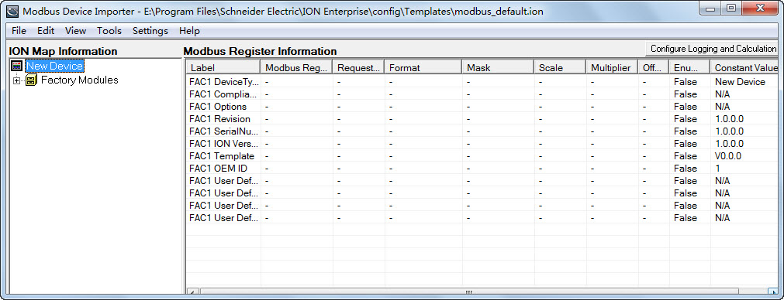
- Right-click the New Device icon from the left pane in the ION Map Information region. Select Advanced Properties from the pop-up dialog box.
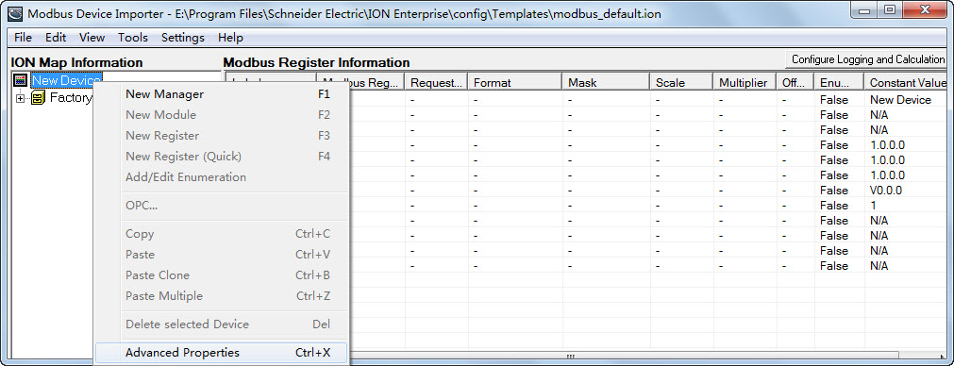
The Device Properties dialog box is shown as follows:
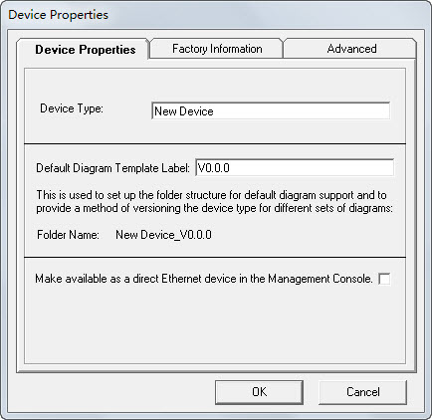
Configure the Device Properties according to your application.
Device Properties Tab
- Device Type: Type the name of the Device Type. For example, name the device as PMC53M if the device model is PMC-53M meter.
- Default Diagram Template Label: The string entered in this field is an internal identifier for the device.
Configure the Device Properties according to your application.
Advanced Tab
- Device Type: Type the name of the Device Type. For example, name the device as PMC53M if the device model is PMC-53M meter.
- Multiple Preset Write check box: Be sure that this check box is selected. PMC-53M requires Multiple Preset Write for time registers so that all time registers be written in a single transaction.
Other settings beneath this tab do not need to be changed.
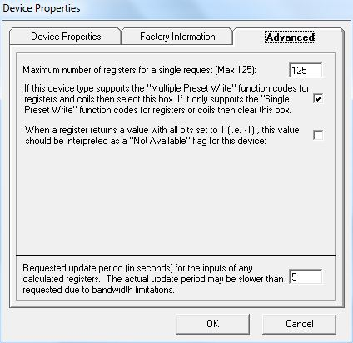
- Right-click the New Device icon from the left pane in the ION Map Information region. Select New Manager from the pop-up dialog box.
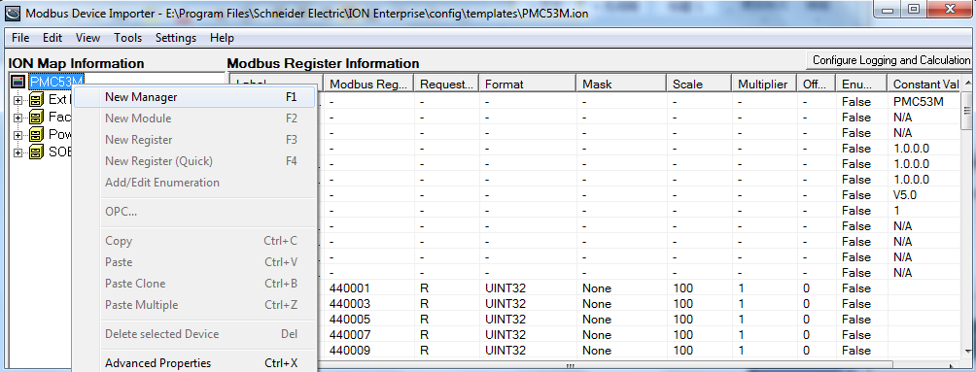
The Add New Manager dialog box appears.
Enter the new manager name into the Manager Name box and select External Numeric Manager type from the Manager Type drop-down button. The manager type determines parameters in the modules and registers under it. The PMC-53M’s time registers are numeric registers.
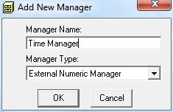
- Right-click the Manager icon from the left pane in the ION Map Information region. Select New Module from the pop-up dialog box.
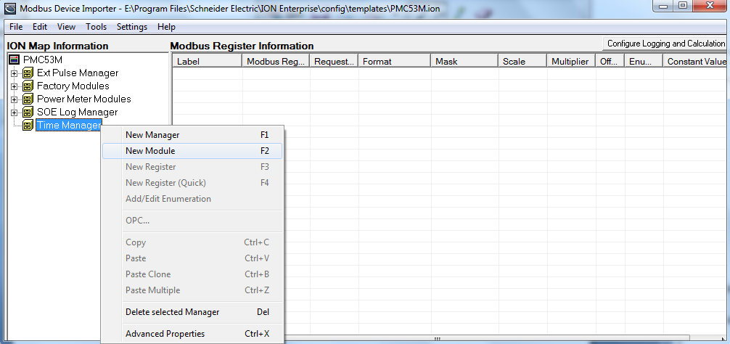
The Add New Module dialog box appears. Enter the new module name into the Module Name box and then click OK. For example, name the module as Clock Module to identify the time parameters.
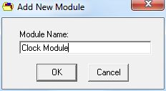
- Right-click the Module icon from the left pane in the ION Map Information region. Select New Register from the pop-up dialog box.
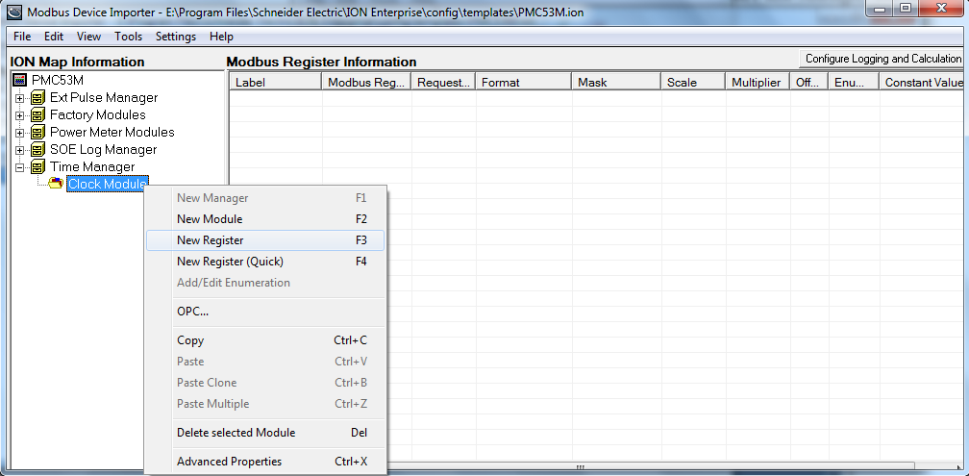
The register properties dialog box appears.
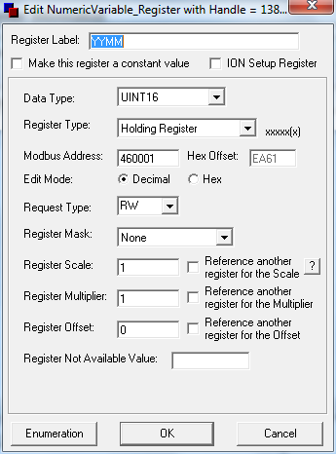
Register Properties
- Register Label: The label is an identifier for the register. For example, name the register as Vln a to identify the phase A voltage.
- Data Type: The data type is used for decoding the values returned from the meter. The selected data type format must match the format delivered by the device. Refer to the Modbus register map for the specific device.
- Register Type: It changes the most significant number in the Modbus address to correspond to the specified register type. The register type must match the register type specified by the device documentation.
- Modbus Address: This is the physical address of the specified register. It must match the register type specified by the device documentation.
- Request Type: This tells the system whether or not it can read, write or do both actions to the specified register. It must match the register type specified by the device documentation.
- Register Scale: This specifies what the scale factor of the data being requested should be. It must match the register type specified by the device documentation.
If all necessary parameters are configured, click OK and return to the main console. The new register appears under the tree in the left pane and detailed information of the register is shown in the right pane.
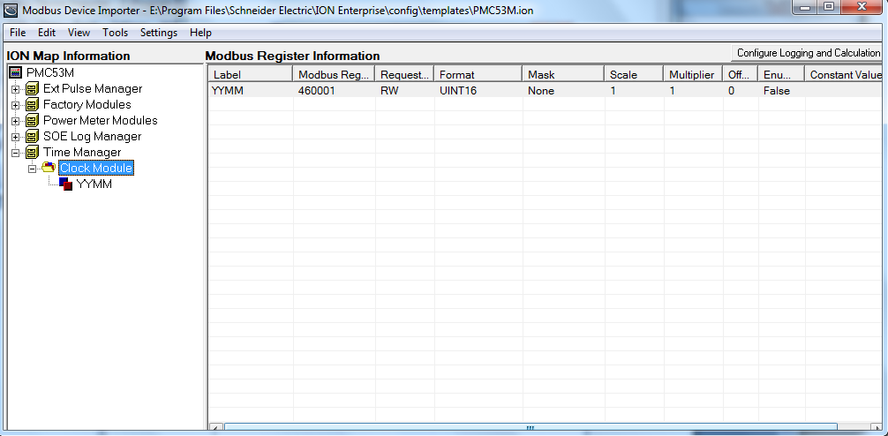
- Add the other time registers according to the device’s Modbus time registers map.
The following shows all the time registers that have been configured.
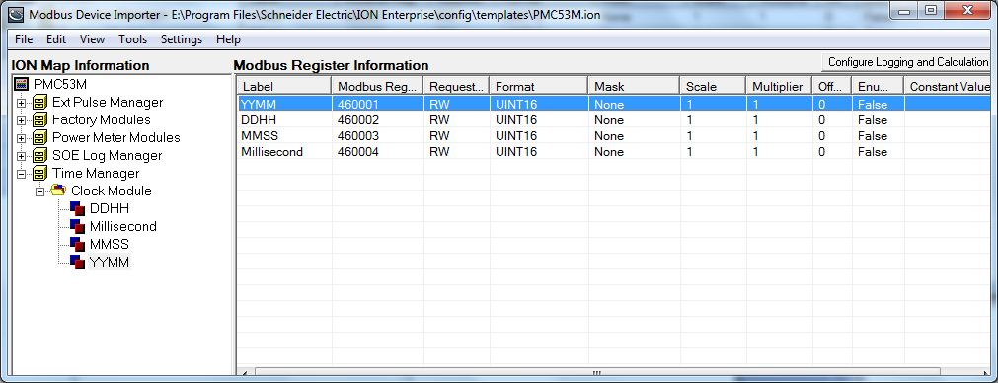
- After adding all the time registers, first navigate to FileSave to save the template, and select ToolsUpdate Device Type to update the NOM to reflect these changes.
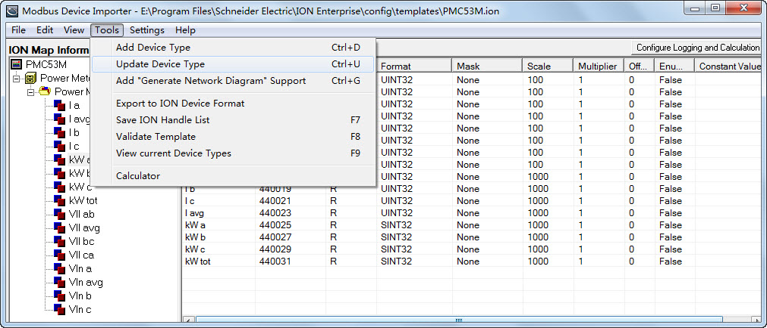
When the hint “Device updated successfully” appears, it indicates that the changes have been updated to the NOM successfully.
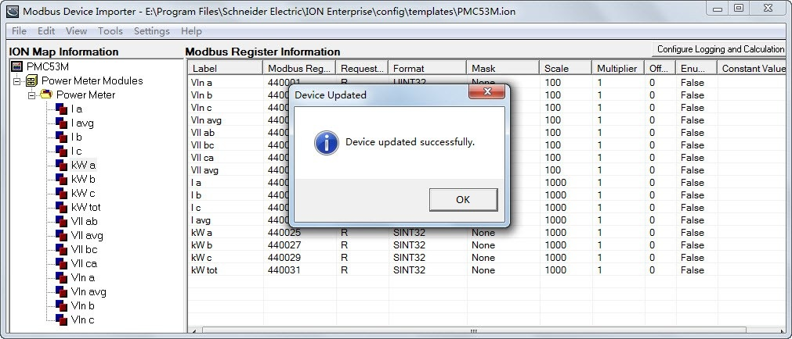

Setting Up VIP Parameters in Management Console
- Launch Management Console. Enter the right user name and password to login.
- Navigate to ToolsSystemION Virtual Processor Setup… from the Management Console user interface.
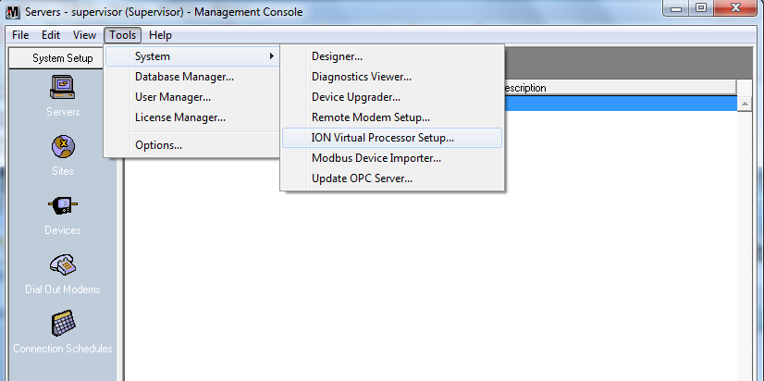
The ION Virtual Processor Setup Window appears as follows:
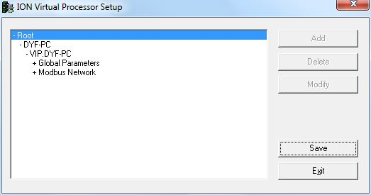
- Configure the VIP site and device.
- Double-click Modbus NetworkMaster Sites on the left-hand pane, and click on the Add Site… button to add a Modbus Master site.
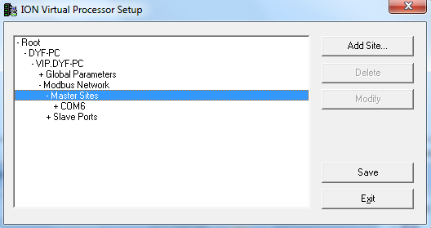
- The VIP Setup Modbus Port/Site window appears as follows. Select the proper port number from the drop-down box beside COM Port, where COMX is the PC’s serial port the PMC-53M device is connecting to. The Virtual Processor’s Modbus Import and Modbus Export Modules use this COM port to communicate to the Modbus Slave device.
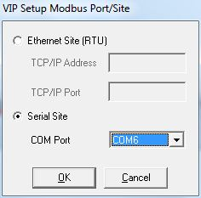
- Double-click COMX on the left-hand pane, and expand the site to show Settings and Devices.
- Double-click Settings to display the parameters under it. Select the parameter you want to change, and then click the Modify… button on the right-hand pane as needed.
- Double-click Devices and click on the Add Device… button to add a Modbus Slave device. Enter the Name and Unit ID of the Modbus device in the appropriate boxes. The communication parameter should match those of the connected device.
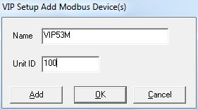
- Save the settings and Exit.
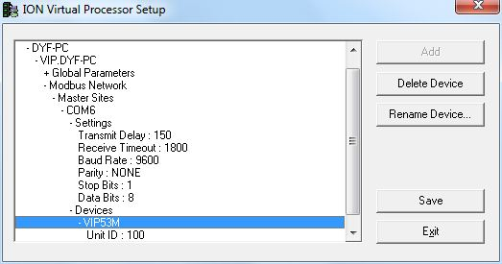
- Disconnect any Direct Site in the Management Console that is using the same serial port.
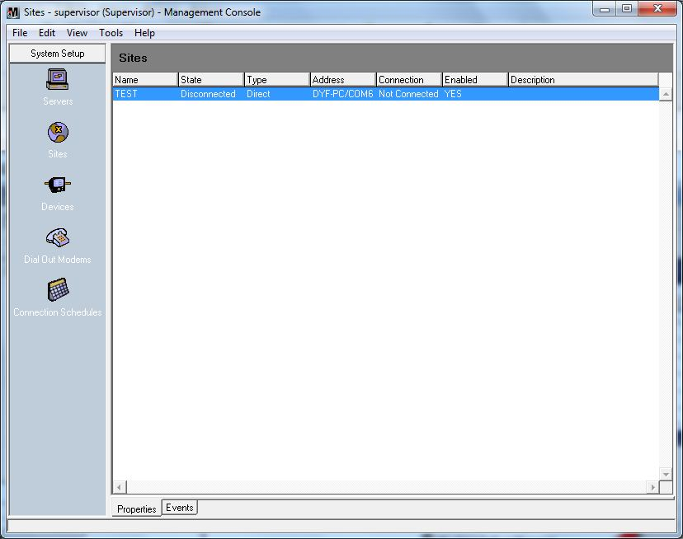
- Restart the ION Virtual Processor Service in Computer Management.
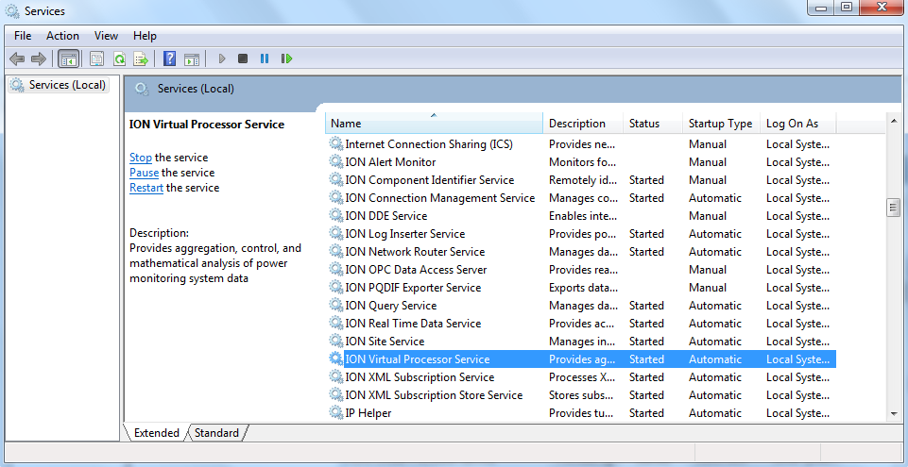
- Start ION Designer and Open the VIP node. Make sure that Options Show Toolbox is selected in order to edit a diagram. Drag a Grouping Object from the toolbox into the VIP diagram. Double-click the grouping object to open it.
- Create the modules in the picture below.
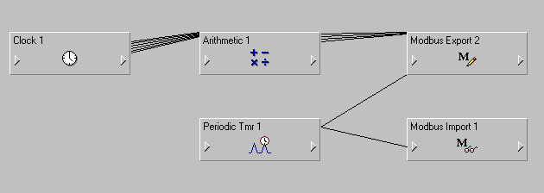
- Drag a Clock module and an Arithmetic module into the window. Link the output registers of the Clock module to the input registers of the Arithmetic module as shown below.
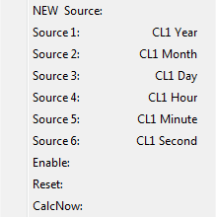
- Set Formula 1 ~ Formula 4 in the Arithmetic module’s Setup registers as shown below. The Arithmetic module is used for transforming the PC’s time to the format of PMC-53M’s time. Output Register 1 ~ Output Register 4 corresponds to year & month, day & hour, minute & second, and millisecond respectively.
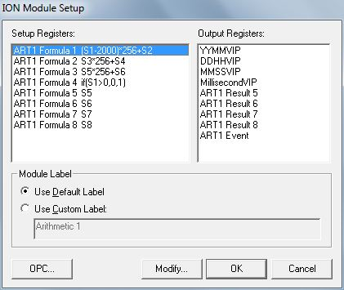
- Drag a Periodic Timer module into the window. Set the Periodic Timer period to 30 seconds.
- Drag a Modbus Export module and a Modbus Import module into the window. Link output register 1 ~ output register 4 of the Arithmetic module to source 1 ~ source 4 of the Modbus Export module as shown below. Link the Trigger output register of the Periodic Timer module to the Modbus Export module’s WriteNow register. As shown below.
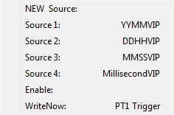
- Set the Modbus Export module as the following picture. The value 460001 in Reg Addr setup register is the start register of PMC-53M’s time.
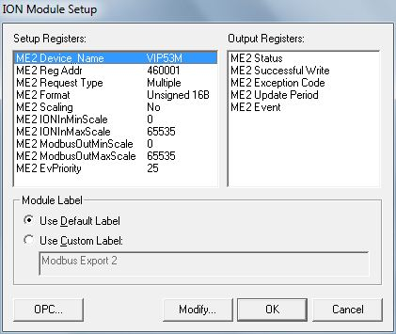
- Link the Trigger output register of the Periodic Timer module to the Modbus Import module’s ReadNow register. As shown below.
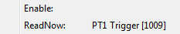
- Set Modbus Import module which points to the same register as that of Modbus Export module; this will be used to verify that PMC-53M is time synchronized. As shown below.
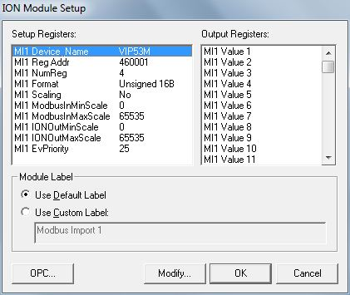
- Save the diagram.
- Hold down the Shift button and click the Modbus Export module’s output symbol to see the output register value. The Status output register value 1 indicates that the last communications attempt succeeded, 0 indicates it did not.
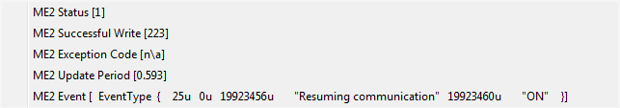
- Hold down the Shift button and click the Modbus Import module’s output symbol to see its output register value. The Value 1 ~ Value 4 output register value 1 contains the current value read from the registers of the Modbus Slave device.
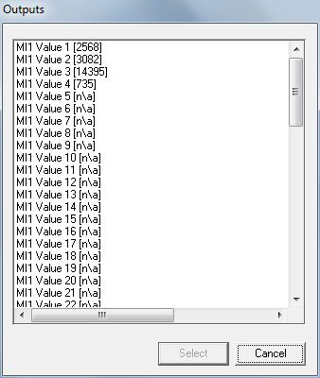
Viewing the PMC-53M time in ION VISTA
- Launch VISTA. Enter the right user name and password to login.
- Select File New to create a new user diagram. Make sure that Options Show Toolbox is selected in order to edit a diagram.
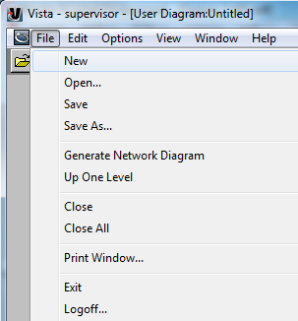
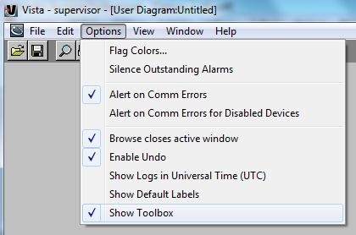
- Right-click on the diagram to select Properties.
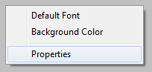
Select the Node tab, choose CustomION, and click on the Select button. Choose the VIP node to link the diagram.
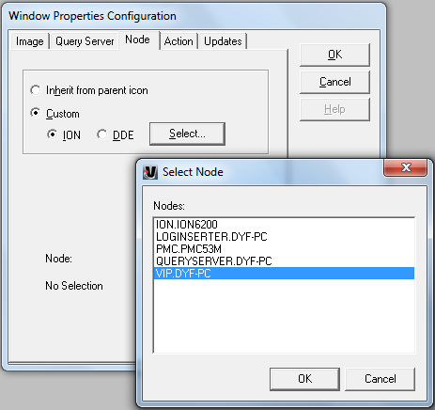
- Drag a Numeric Object from the tool bar to the diagram.
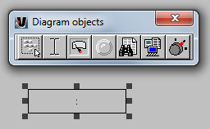
Right-click on the Numeric Object and select Inherit from parent window under the Link tab and click on the Edit Link… button.
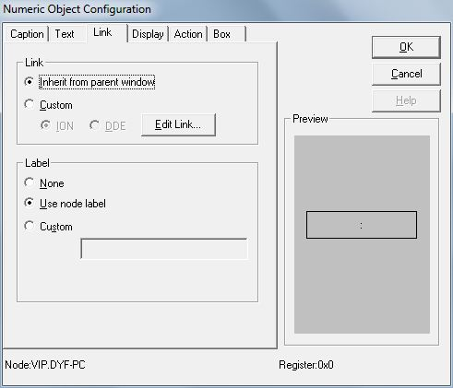
- Search for the Modbus Import Module created in Designer, and select the first output register, click OK to confirm. Now the Numeric Object is showing the register value.
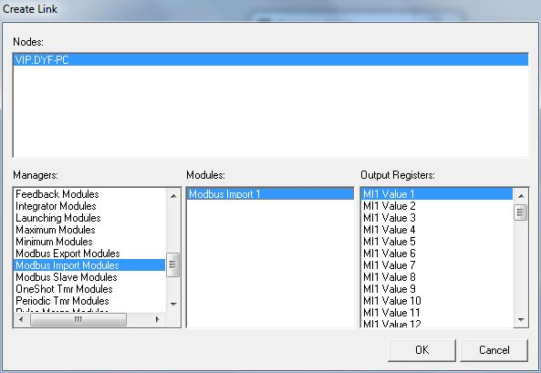

You can also verify the data and time from the PMC-53M’s LCD.

